**What is a Perceptron in Deep learning?**

--------------------------------------------------------------------------------------------------------------

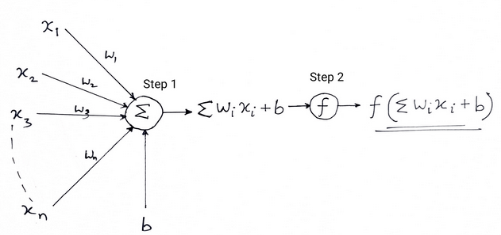

A perceptron is the simplest type of artificial neuron and a building block in deep learning.

**Structure:** It mimics a **biological neuron** and consists of:

* **Inputs**: x1,x2,...,xn
* **Weights**: w1,w2,...,wn
* **Bias**: b
* **Activation Function**: e.g., step, sigmoid, ReLU

Mathematical Form:

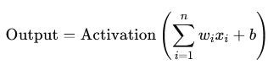

In classic perceptron:

* Activation function = Step function
  + Output = 1 if weighted sum > threshold
  + Output = 0 otherwise

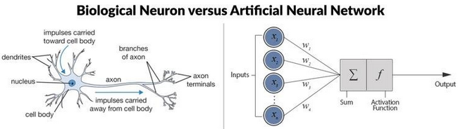

**What are Perceptrons Used For?**

Binary Classification

* Early perceptrons were used to classify data into two classes (e.g., spam or not spam).

Foundation of Neural Networks

* Perceptrons are the basic unit of larger networks.
* Multi-Layer Perceptrons (MLPs) = networks of many perceptrons.
* When you connect many perceptrons with nonlinear activations → you get deep neural networks.

**Limitations of Single Perceptron**

* Can only solve linearly separable problems.
* Can't solve XOR problem.
* That’s why we use multi-layer perceptrons (MLPs) with non-linear activation functions in modern deep learning.

**Summary:**

| **Feature** | **Perceptron** |
| --- | --- |
| What is it? | A single-layer neural unit |
| Introduced by | Frank Rosenblatt |
| Good for | Simple binary classification |
| Not good for | Non-linear or complex problems |
| Extended into | Multi-Layer Perceptron (MLP), Deep Neural Networks |
| Uses | Foundation of deep learning, logic gates, image recognition (early days) |